**AES Encryption and Decryption Web Application - Project Report**

**1. Introduction**

The Advanced Encryption Standard (AES) has become the cornerstone of modern cryptography since its adoption by NIST in 2001. This project demonstrates the practical implementation of AES encryption and decryption through a web-based application built using Python Flask framework and the cryptography library.

AES is a symmetric block cipher that processes data in 128-bit blocks and supports key lengths of 128, 192, and 256 bits. The algorithm's strength lies in its mathematical foundation and resistance to various cryptanalytic attacks, making it suitable for protecting sensitive information across numerous domains.

This implementation showcases AES in Cipher Block Chaining (CBC) mode, which provides semantic security by ensuring that identical plaintext blocks produce different ciphertext blocks when encrypted with the same key.

**2. Understanding AES Block Cipher Principles**

**2.1 Symmetric Encryption**

AES operates as a symmetric cipher, meaning the same secret key is used for both encryption and decryption operations. This characteristic makes it efficient for scenarios where both parties can securely share the encryption key beforehand.

**2.2 Key Sizes and Security Levels**

The three supported key sizes offer varying levels of security:

* **AES-128**: 16-byte key, 10 transformation rounds
* **AES-192**: 24-byte key, 12 transformation rounds
* **AES-256**: 32-byte key, 14 transformation rounds

Each round involves four main operations: SubBytes (substitution), ShiftRows (permutation), MixColumns (diffusion), and AddRoundKey (key mixing).

**2.3 CBC Mode Implementation**

Cipher Block Chaining mode addresses the weakness of Electronic Codebook (ECB) mode by XOR-ing each plaintext block with the previous ciphertext block before encryption. This approach ensures that identical plaintext blocks produce different ciphertext outputs, enhancing security.

**3. Python Implementation Details**

**3.1 Library Selection**

I chose Python's cryptography library over alternatives like PyCryptodome due to its:

* Active maintenance and security updates
* Comprehensive documentation
* Strong community support
* Integration with modern Python applications

**3.2 Core Implementation Code**

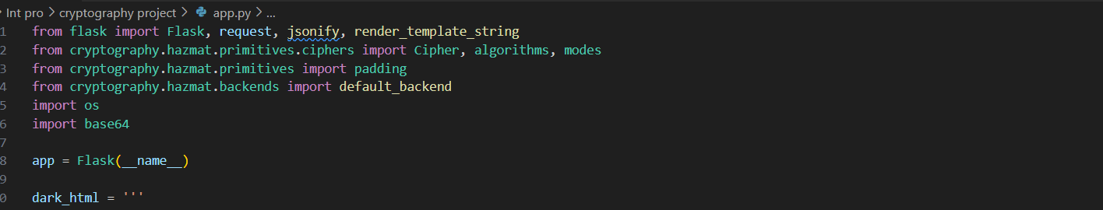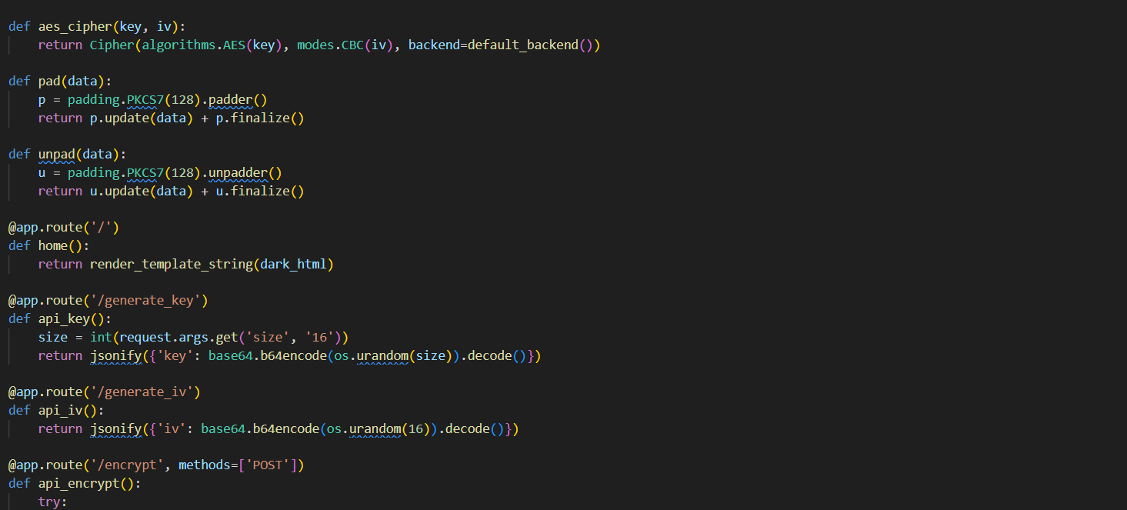

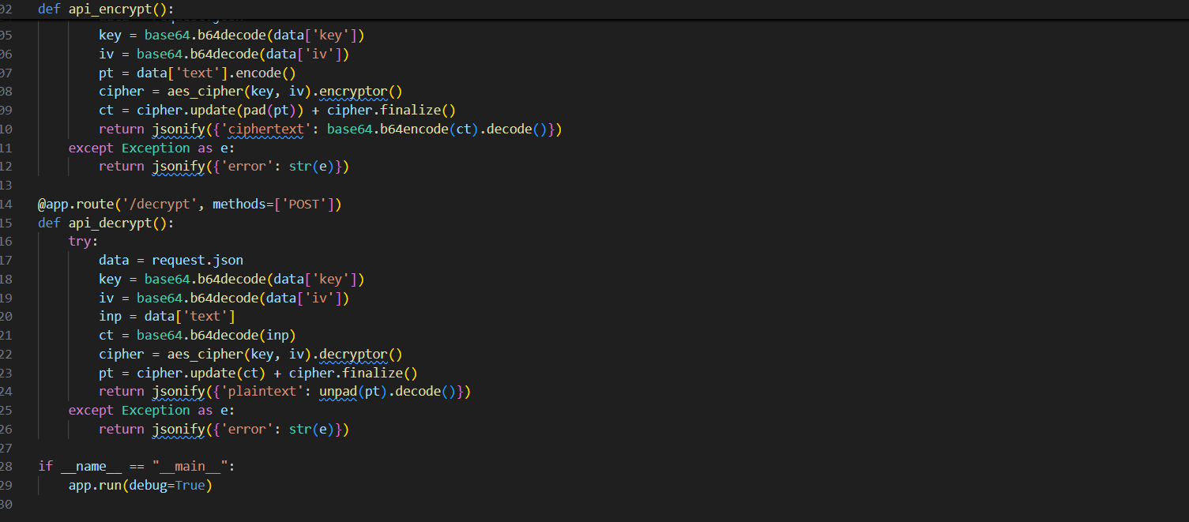

**3.3 Web Interface Design**

The frontend utilizes modern web technologies with a focus on usability:

* Responsive design for various screen sizes
* Dark theme for reduced eye strain
* Real-time feedback for user interactions
* Clear separation of input and output areas

**4. Input and Output Analysis**

**4.1 Input Requirements**

The application accepts the following inputs:

* **Plaintext**: User-provided text for encryption (unlimited length)
* **Secret Key**: Base64-encoded key of 16, 24, or 32 bytes
* **Initialization Vector**: Base64-encoded 16-byte random value

**4.2 Processing Workflow**

1. User enters plaintext message
2. System generates cryptographically secure key and IV
3. Plaintext undergoes PKCS7 padding to meet block size requirements
4. AES encryption produces ciphertext using CBC mode
5. All outputs are encoded in Base64 for safe transmission

**4.3 Output Format**

* **Ciphertext**: Base64-encoded encrypted data
* **Decrypted Text**: Original plaintext after successful decryption
* **Error Messages**: Clear feedback for invalid operations

**5. AES Applications in Modern Computing**

**5.1 Network Security**

AES forms the foundation of secure network communications:

* **Wi-Fi Security**: WPA2 and WPA3 protocols use AES for protecting wireless transmissions
* **VPN Tunneling**: Virtual Private Networks rely on AES to encrypt data between endpoints
* **SSL/TLS**: Web browsers use AES within HTTPS connections to secure online transactions

**5.2 Data Protection**

Organizations implement AES for data-at-rest encryption:

* **Database Encryption**: Sensitive database fields are encrypted using AES algorithms
* **File System Security**: Operating systems like Windows (BitLocker) and macOS (FileVault) use AES
* **Cloud Storage**: Services like Google Drive and Dropbox encrypt user files with AES

**5.3 Application-Level Security**

Software applications integrate AES for various security needs:

* **Messaging Applications**: WhatsApp, Signal, and Telegram use AES for end-to-end encryption
* **Password Managers**: Tools like LastPass and 1Password encrypt stored credentials with AES
* **Digital Wallets**: Cryptocurrency wallets protect private keys using AES encryption

**6. Comparison with Classical Ciphers**

**6.1 Security Analysis**

Classical ciphers like Caesar and Vigenère suffer from fundamental weaknesses:

**Caesar Cipher Limitations:**

* Only 25 possible keys (easily brute-forced)
* Vulnerable to frequency analysis
* No protection against pattern recognition

**Vigenère Cipher Weaknesses:**

* Repeating key patterns create vulnerabilities
* Susceptible to Kasiski examination
* Short keys provide minimal security

**AES Advantages:**

* Massive key space (2^128, 2^192, or 2^256 possibilities)
* Resistance to differential and linear cryptanalysis
* No known practical attacks against full-round AES

**6.2 Computational Complexity**

* **Classical Ciphers**: Can be broken in seconds using basic computers
* **AES**: Would require billions of years to break using current technology
* **Quantum Resistance**: AES-256 remains secure even against theoretical quantum computers

Github Repository Link:

<https://github.com/alwinajai/AES-CIPHER-TEXT>

**7. Conclusion**

This project successfully demonstrates the practical implementation of AES encryption in a web-based environment. The combination of Python's cryptography library with Flask framework provides a robust foundation for understanding modern cryptographic principles